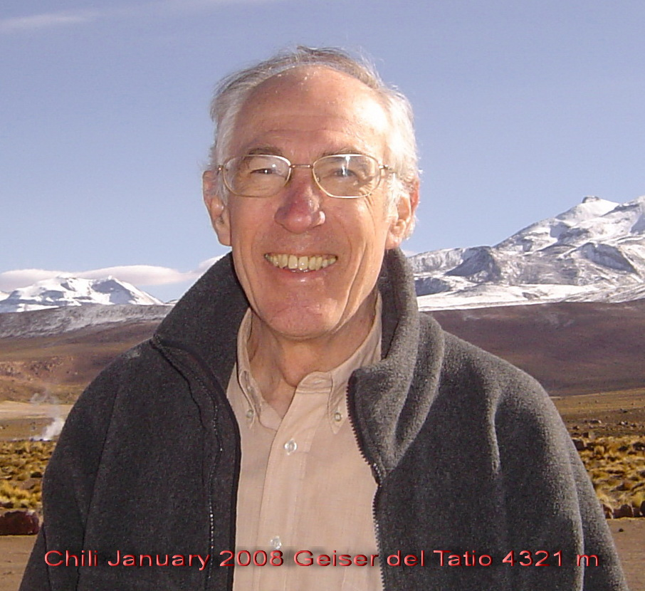 | André BERGER  Université catholique de Louvain  Earth and Life Institute  Georges Lemaître Center for Earth and Climate Research  (formerly Institut d'Astronomie et de Géophysique G. Lemaître)  Place Louis Pasteur, 3  B-1348 Louvain-la-Neuve, Belgium  Tel. +3210473303  Fax. +3210474722  Email andre.berger@uclouvain.be  http://www.climate.be/u/berger  Institute: http://www.uclouvain.be/teclim.html  ftp://ftp.elic.ucl.ac.be/ berger
André Berger is Master of Science in Meteorology from M.I.T. (1971) and Doctor of Science from the Université catholique de Louvain (Belgium) (1973). He was Ordinary Professor at the Catholic University of Louvain (UCL) where he lectured on meteorology and climate dynamics. He is Emeritus Professor and Senior Researcher at UCL, doctor honoris causa from the Universities of Aix-Marseille III in 1989, of the Université Paul Sabatier de Toulouse (1999), of the Faculté Polytechnique de Mons (2004) and of the University of Massachusetts Amherst (2013). He was made Honorary distinguished Professor of the Yunnan Normal university, Kunming, China in 2014. He was C.R.B. graduate fellow of the Belgian American Educational Foundation, professor at the Vrije Universiteit Brussel, at the Université de Liège and was invited to deliver lectures and seminars in many universities at the international scale. He is a member of the Académie des Sciences, des Lettres et de Beaux Arts in Belgium (since 2002) and of Academia Europaea (since 1989); he is a foreign member of the Koninklijke Nederlandse Akademie van Wetenschappen (1997), associate foreign member of the Académie des Sciences de Paris (2000), of the Serbian Academy of sciences and Arts (2006), of the Société Royale du Canada (2007), of the Académie Nationale de l’Air et de l’Espace and of the Royal Astronomical Society (2003). He was Director of the Classe des Sciences of the Académie royale de Belgique (2017). He received the Lemaître Prize 2010 of the Mgr Lemaître Foundation, the European Latsis Prize of the European Science Foundation in 2001, the Prix quinquennal of the Belgian National Funds for Scientific Research for 1991-1995, the Norbert Gerbier-Mumm International Award from the World Meteorological Organization in 1994, the Milutin Milankovitch Medal of the European Geophysical Society 1993, the Prix Charles Lagrange of the Classe des Sciences de l’Académie royale de Belgique in 1984 and the Prize of the first biennial 1979-1980 of the Societa Italiana di Fisisca (geophysical section). He has been responsible for 78 research grants, among which a 2008 European Research Council Advanced Investigators Grant (ranked top of the list).

He was chairman of the International Climate (IAMAS-IUGG) and the International Paleoclimate (INQUA) Commissions, president of the European Geophysical Society and is Honorary President of the European Geo-Sciences Union. He is fellow of the American Geophysical Union and of the Royal Meteorological Society. He is a co-founder of the International Polar Foundation (1999). He was a member of the Conseil scientifique consultatif auprès de Météo-France (2001-2012), of the Conseil de l'Environnement d'Electricité de France (1998-2009), of the Scientific Committee of the European Environment Agency (2002-2008) and of the Conseil scientifique de Gaz de France (1994-1999), of the Comité d’Orientation Scientifique et Stratégique du Collège de France (2003-2006) and of the Conseil Scientifique International du Pôle Européen Universitaire et Scientifique de Grenoble (2000-2006). He was chairman of the External advisory group on Global Change, Climate and Biodiversity (1998-2002) and of the Coordination Group on Climate Processes and Climate Change (1988-1992), both of the Commission of the European Communities and of the NATO Special Programme Panels on the Science of Global Environmental Change (1992) and Air-Sea Interactions (1981), of the international technical Meeting on Air Pollution Modeling and its Applications (1980-1985) of NATO and of the Working Group on Modeling Paleoclimate (1984-1990) of the European science foundation. He served in many Scientific Councils of Research Institutes and in advisory boards of industries and ministries. He is the instigator of the creation of the Milutin Milankovitch Medal of the European Geophysical Society/Geosciences Union in 1993 and of the American Geophysical Union Climate Medal which was named Roger Revelle in 1992. He was and continues to be invited to lecture in many universities and to deliver papers in specialized symposia.

He is the author of "Le Climat de la Terre, un passé pour quel avenir ?", has edited 15 books on climatic variations and has published more than 300 papers on this subject. He is editorial board member of The Holocene, Climate Dynamics and Earth and Planetary Science Letters. He was editor of EOS for Atmospheric Sciences, associate editor of Surveys in Geophysics and Atmospheric Environment and board member of Climatic Change. His main research is about modeling climatic changes at the geological time scales. He has made notable contributions to the astronomical theory of paleoclimates. He has contributed significantly to the revival of the astronomical theory of paleoclimates which aims to explain the glacial-interglacial cycles from the long-term variations of the astronomical parameters of the Earth orbit around the Sun and of its axis of rotation. He was the first to provide a full list of the periods characterizing them, in particular the 400,000 year cycle, and their origin. The climate model that he has developed with his team is also used for simulating the response of the climate system to human activities and the possible impacts on the natural course of climate at the geological time scale. It is acknowledged to be the first model of intermediate complexity having been created.

André Berger is a cited pioneer of the interdisciplinary study of climate dynamics and past climate history. He has been ennobled by His Majesty Albert II, King of the Belgians, with the title of Chevalier (Sir; motto “Lux Scientia et Labora”), received the title of Officier de la Légion d'Honneur from the President of France and is Grand Officier de l'Ordre de Léopold in Belgium.

